**Activity 1: Query Optimization Challenge  
  
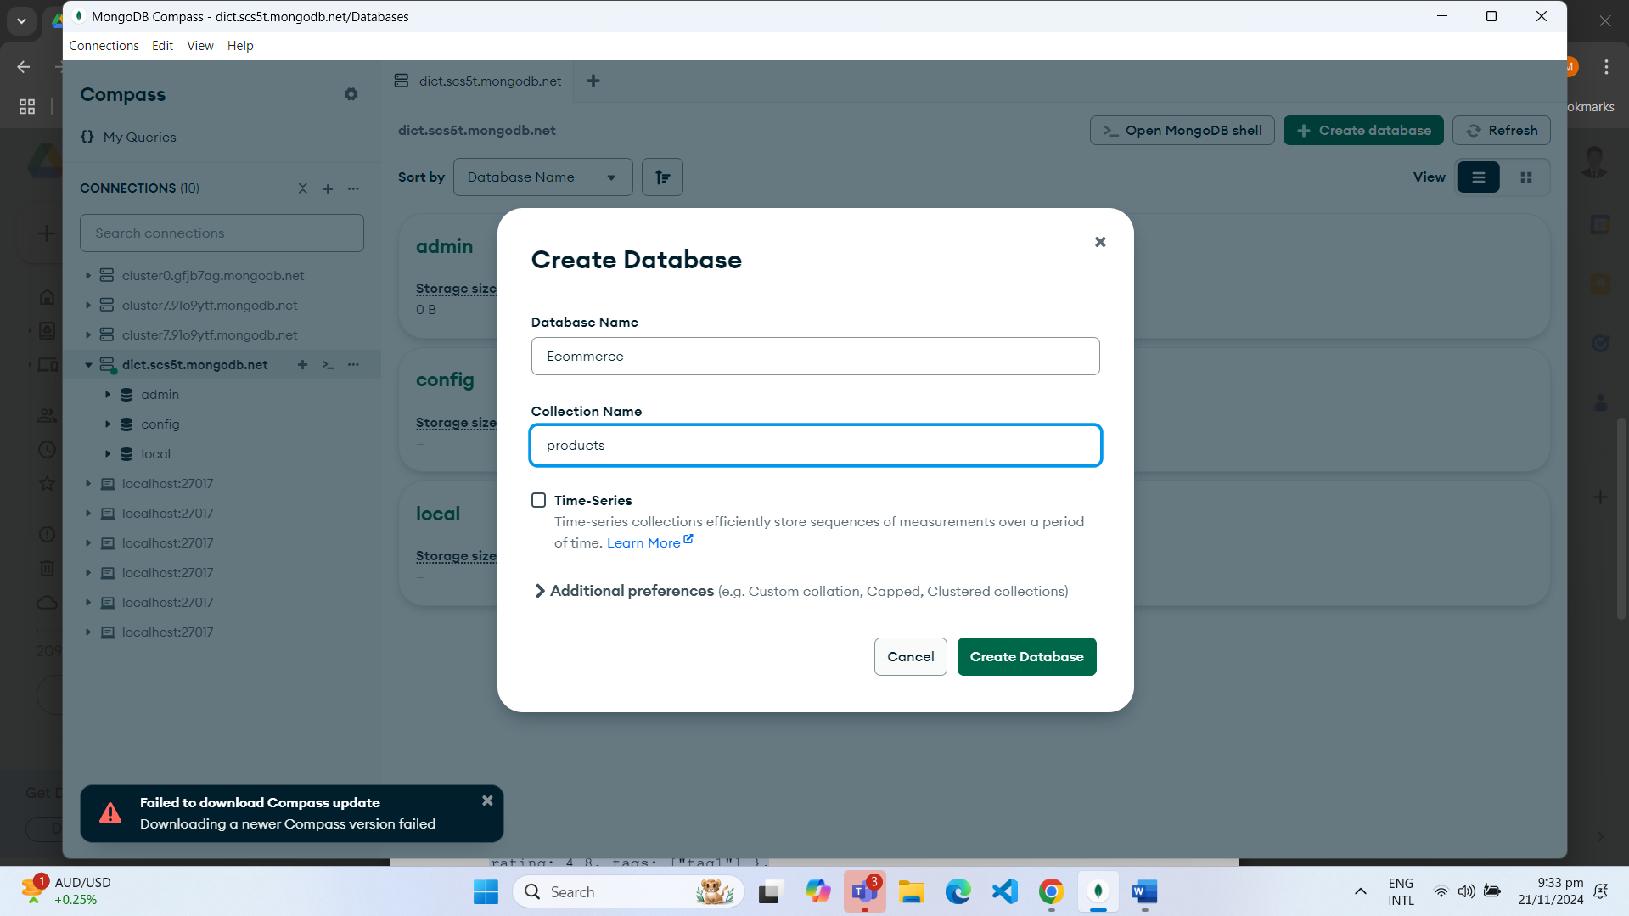  
  
  
  
  
  
  
Inserted Products  
  
  
Inserted orders  
  
**Step 1: Find all products with a price greater than $100 and a rating above 4.5:  
  
Step 2: Find the average rating for products in each category:  
  
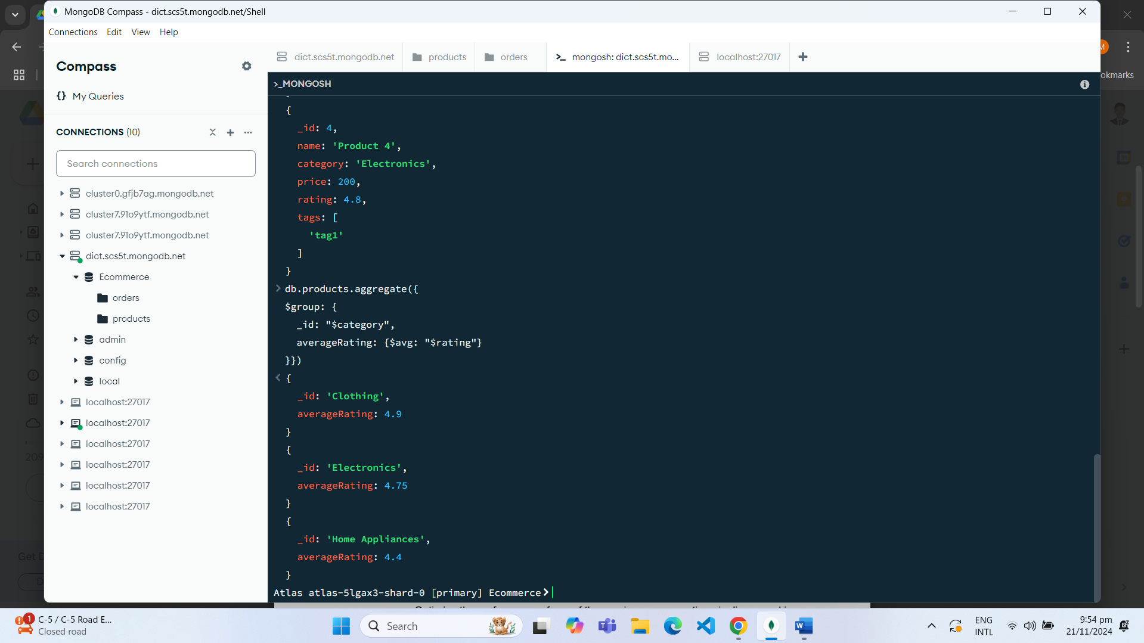

c. Step 3: Find the top 5 customers with the highest number of orders:  
  
Step 4: Find the most common tags across all products:

Write an aggregation pipeline that groups products by tags and counts their occurrences. Sort the results in descending order based on the tag count.  
  
